

Dr. Jeffrey, Carter inc.

2015-09-15

Dr. Carter

USNS Saunders, FPO AP 50601

Phone: 7700873475

Fax: 8576503852

**Re:** Danielle, Holmes

**PHN:** 5310292789

**Birthdate:** 23-Apr-1942

**Address:** 43771 Elizabeth Circle Suite 934, Allenburgh, TX 53099

**Patient number:** 4138493282

To Whom It May Concern:

This is a medical letter to state the above patient is pregnant with expected delivery date of 24-May-2025. Hoping this information is satisfactory for your requirements.

Thank you.

Sincerely,

Dr. Jeffrey, Carter

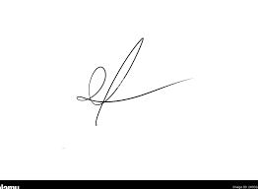

FRCS© NCMP

Clinical Assistant Professor, UBC

Department of Obstetrics and Gynecology SMH